|  |
| --- |
| Software Development Team |
| Let’s Quiz |
| UI Documentation |

|  |
| --- |
|  |

1. Contents

2 Screens 1

2.1 Splash 1

2.1.1 Purpose 1

2.1.2 Components 1

2.1.3 Screenshot 1

2.2 Login 1

2.2.1 Purpose 1

2.2.2 Components 1

2.2.3 Screenshot 2

2.3 Menu 6

2.3.1 Purpose 6

2.3.2 Components 6

2.3.3 Screenshot 6

2.4 Game 7

2.4.1 Purpose 7

2.4.2 Components 7

2.4.3 Screenshot 7

2.5 Result 8

2.5.1 Purpose 8

2.5.2 Components 8

2.5.3 Screenshot 9

2.6 Account (Unneeded at the moment) 9

2.6.1 Purpose 9

2.6.2 Components 9

2.6.3 Screenshot 9

2.7 Leader Board 9

2.7.1 Purpose 9

2.7.2 Components 9

2.7.3 Screenshot 9

2.8 Submit Question 9

2.8.1 Purpose 9

2.8.2 Components 9

2.8.3 Screenshot 9

2.9 Settings 10

2.9.1 Purpose 10

2.9.2 Components 10

2.9.3 Screenshot 10

3 Process Flow 11

3.1 New User 11

3.2 Existing User 12

# Screens

## Splash

### Purpose

* Try and establish connection between app and SQL server. If app can’t establish connection, user is given a choice to retry establishing the connection or quitting out of the application.
* Downloads question pool
* Checks if user has already logged in, if they have - goes straight to menu screen otherwise goes to login screen where the user selects if they wish to login or register.

### Components

* Logo
* Error Modal

### Screenshot

|  |  |  |
| --- | --- | --- |
| **Entry** | **Entry Progress** | **Connection Unavailable** |
|  |  |  |

## Login

### Purpose

* Register for app account if not already a member
* Login to app account if already a member and they have logged out for some reason
* Provide way for user to skip registering or logging if they so wish
* Provide user with ability to login with a social media account if they so wish

### Components

#### Entry specific

* Button to show login panel
* Button to show registration panel

#### Register Specific

* Username Input
* Email Address Input
* Password Input
* Confirm Password Input
* Register Button

#### Login Specific

* Username Input
* Password Input
* Login Button

#### Common

* Logo
* Heading
* Error Modal
* Error Alert
* Skip Button
* Login with Google Button
* Login with Facebook Button

### Screenshot

#### Entry

|  |  |  |
| --- | --- | --- |
| **Entry** |  |  |
|  |  |  |

#### Register

|  |  |  |
| --- | --- | --- |
| **Entry** | **Registering** | **Skip Registering** |
|  |  |  |
|  | | |
| **Empty Username** | **Empty Email Address** |  |
|  |  |  |
|  | | |
| **Empty Password** | **Empty Confirm Password** | **Passwords Don’t Match** |
|  |  |  |

#### Login

|  |  |  |
| --- | --- | --- |
| **Entry** | **Logging In** | **Skip Logging In** |
|  |  |  |
|  | | |
| **Empty Username** | **Empty Password** | **Invalid User** |
|  |  |  |

## Menu

### Purpose

* (Not needed yet) Provide user with information about the status of any games they are engaged in
* Provide user with functionality to start a new game
* (Not needed yet) Provide user with functionality through a navigation drawer to;
  + Access account specific settings
  + Access leader board
  + Access submit question functionality
  + Access app specific settings
* Provide user with logout functionality
* Provide user with quit functionality

### Components

* Welcome back Alert
* Menu Toggle (Not developed yet)
* List of games where it’s the users turn (Not needed yet)
* List of games where it’s the opponents turn (Not needed yet)
* New Game Button
* Text to display username
* Button to access account settings
* Button to access leader board
* Button to access submitting a question functionality
* Button to access app specific settings
* Button for logging out
* Button for quitting

### Screenshot

|  |  |
| --- | --- |
| **User** | **Guest** |
|  |  |

## Game

### Purpose

* Provide user with information about which opponent they are currently playing against
* Provide user with timer feedback on how long they have left to answer the question
* Display question text
* Display answers as buttons
* Provide feedback on correct and incorrect answer
* Provide report question functionality
* Provide like question functionality
* Display user score

### Components

* Text to display which game the user is playing (Not needed yet)
* Bar to display time remaining on question
* Text to display question
* Buttons to display answers
* Button to like question
* Button to report question
* Text to display score

### Screenshot

|  |  |  |
| --- | --- | --- |
| **Entry** | **Correct Answer** | **Incorrect Answer** |
|  |  |  |
|  | | |
| **Timer Progress - Max** | **Timer Progress - Mid** | **Timer Progress - Min** |
|  |  |  |

## Result

### Purpose

* Provide user with what achievements they have received – functionality provided by social media integration
* Provide the user with the results of their game against another user
* Provide navigation back to menu
* Provide sharing functionality provided by social media integration

### Components

* Achievement badge panel (is available, just not active in screenshots)
* Username display
* Won / Lost display
* Share results Button
* Back to menu button

### Screenshot

|  |  |
| --- | --- |
| **User** | **Guest** |
|  |  |

## Account (Unneeded at the moment)

### Purpose

### Components

### Screenshot

## Leader Board

### Purpose

### Components

### Screenshot

|  |  |
| --- | --- |
| **User** |  |
|  |  |

## Submit Question

### Purpose

* Provide users with the functionality to add questions to the database

### Components

* Input fields for;
  + Question
  + Correct answer
  + Incorrect answers
* Button to submit question

### Screenshot

#### User

|  |  |  |
| --- | --- | --- |
| **Entry** | **Submission Successful** | **Submission Unsuccessful** |
|  |  |  |
|  | | |
| **Question** | **Correct Answer** | **Incorrect Answer 1** |
|  |  |  |
|  | | |
| **Incorrect Answer 2** | **Incorrect Answer 3** |  |
|  |  |  |

## Settings

### Purpose

* Provide user with the ability to turn sound effects on or off
* Provide user with the ability to turn background music on or off
* Provide user with the ability to turn push notifications on or off (Notifications aren’t integrated yet)

### Components

* Back button
* Screen Heading
* Toggle for;
  + Sound effects
  + Background music
  + Push notifications

### Screenshot

|  |  |
| --- | --- |
| **Settings On** | **Settings Off** |
|  |  |

# Process Flow

## New User

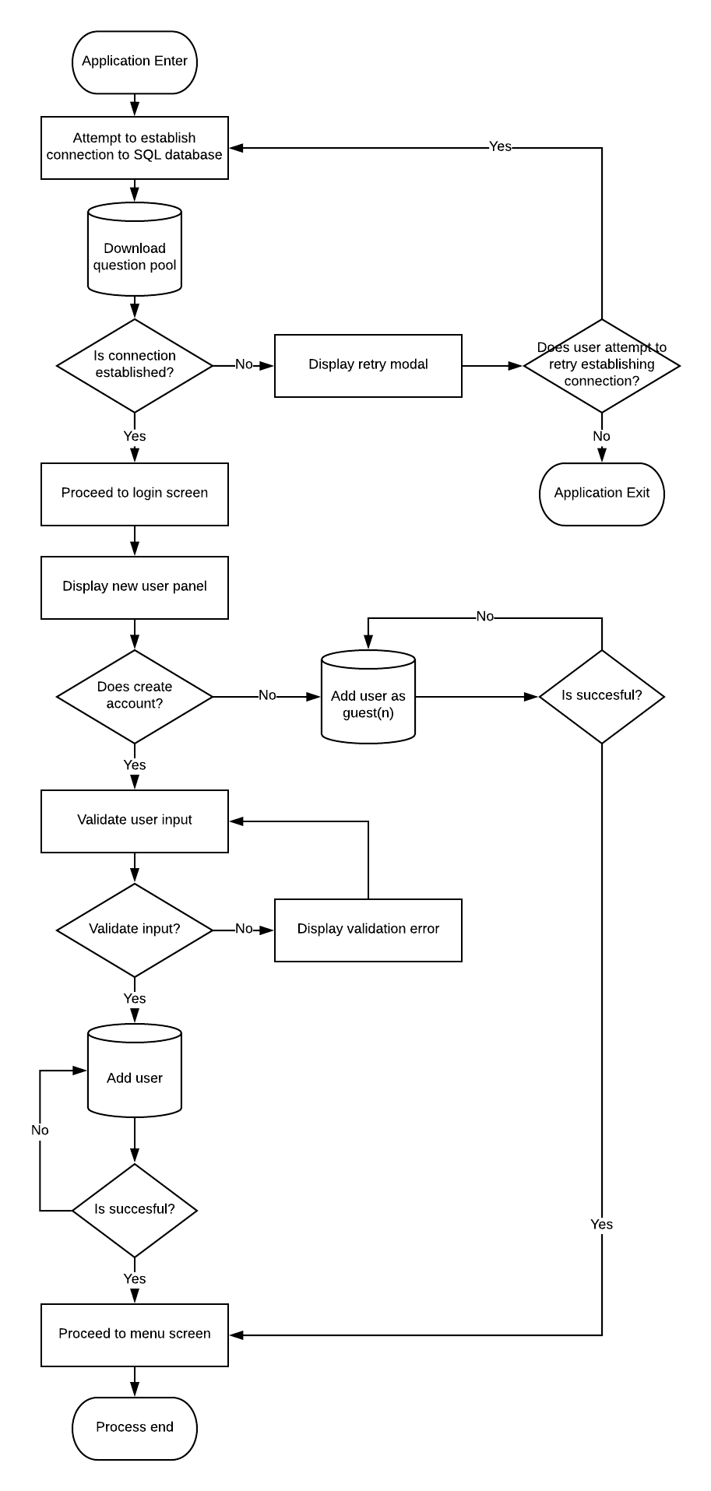

## Existing User

